
ICS 65.020.01
B 04

National Standard of the People’s Republic of China
GB/T 19630.3-2011

Organic Products
Part 3：Labeling and Marketing

Issued on 2011-12-05
Enforced on 2012-03-01
Issued by General Administration of Quality Supervision, Inspection and Quarantine of the People’s Republic of China
Standardization Administration of the People’s Republic of China

Table of Contents

Foreword

GB/T 19630 Organic Products consists of four parts:
- Part 1: Production;
- Part 2: Processing;
- Part 3: Labeling and Marketing; and,
- Part 4: Management System.
This is the third part of GB/T 19630.
This part was prepared in line with GB/T 1.1-2009。

This part replaces GB/T 19630.3-2005 Organic Products Part 3: Labeling and Marketing. Compared with GB/T 19630.3-2005, the main technical changes are as follows:
——addition of the restrictions on use of characters, graphics or symbols indirectly hinted as organic product (see 4.2);
——addition of the requirements of “Labeling shall not mislead consumers with products of conventional as conversion to organic, or products in conversion to organic as organic.”( see 4.3);
——removal of the requirements on characters on labels (see 4.5 of the 2005 version);
——removal of the requirements on labeling of exported products in line with foreign standards or importer’s requirements defined in contracts with foreign buyers (see 4.7 of the 2005 version);
——removal of the requirements on the organic logo of certification body(see 5.1, 5.2, 7.2, and 7.3 of this version, and 5.1, 5.2, 5.3, and 8 of 2005 version)；
——modification of the way of data handling of the results of organic ingredient percentage calculation to rounding down to the nearest whole number, and changes the description into English letters (see 6.2, 6.3, 6.4);
——addition of the requirements of “Products labeled as organic shall label Organic Product Certification Seal of China/In Conversion to Organic Products Seal of China and its sole identification number, certification body’ name or its logo, on products or the smallest package of the products(see 7.2);
——addition of the requirements on the way of use of Organic Product Certification Seal of China/In Conversion to Organic Products Seal of China on products or the packages of the products (see 7.3);
——addition of the requirement of “the sellers shall request suppliers to provide organic product transaction certificate” (see 8.2);
——removal of the requirements of “products not complying with the requirements of this part of GB/T 19630 shall not be sold as organic products”(see 9.6 of 2005 version).
Please note that some sections of this Part maybe relevant to patents. The distribution authority of this Part shall not take the responsibilities of identifying these patents concerned.
This part was proposed by Certification and Accreditation Administration of the People’s Republic of China.
This part was prepared by China National Institute of Standardization of China, Organic Food Development and Certification Center of China, China National Accreditation Service for Conformity Assessment, Beijing Entry-Exit Inspection and Quarantine Bureau, Center for Standard and Regulation of General Administration of Quality Supervision, Inspection and Quarantine of the People’s Republic of China, Beijing Continental Hengtong Certification Co., Ltd, China Agricultural University
This part was drafted by YANG Li, YU Kaijin, XIE Weihua, LIU Junhua, QIAO Yuhui, YANG Zhigang, CHEN Yunhua, XU Na, WANG Maohua, FU Qiang, WU Xingxia, MENG Dong, QU Li, LIU Wen, MENG Fanqiao
Previous issues replaced by this part：
——GB/T 19630.3-2005.
Organic Products
Part 3: Labeling and Marketing
1 Scope
This part of GB/T 19630 defines the general criteria and requirements for organic products labeling and marketing.
This part applies to operations of labeling and marketing of products produced, processed and certified in compliance with the requirements set forth in GB/T 19630.1 and/or GB/T 19630.2.

2 Normative references
The following normative documents are essential for the implementation of this document. For dated references, only the dated version references apply. For undated references, the latest edition of the publications (including the list of revision) referred to apply.
GB/T 19630.1 Organic Products Part 1: Production
GB/T 19630.2 Organic Products Part 2: Processing
GB/T 19630.4 Organic Products Part 4: Management System
3 Terms and definitions
Terms and definitions listed hereafter apply to this document.
3.1 Labeling
All written and printed characters or graphics presented on the sold products, product packages, product labels or instruction materials accompanying or referring to the products.
3.2 Certification Seal
Symbols, graphics and/or combination of symbols, graphics and characters, which prove the compliance of organic production and processing with this Standard.
3.3 Marketing
Activities of selling in the form of wholesale, direct distribution, exhibition, franchise, distribution, retail or any other activities of placing products on the market.

4 General rules
4.1 Labeling of organic products shall comply with requirements laid down in relevant governmental laws, regulations and standards.
4.2 The term “organic,” characters, graphics or symbols indirectly hinted as organic product, and the Organic Product Certification Seal of China shall only be used on labels of organic products produced and/or processed in compliance with the requirements established in GB/T 19630.1, GB/T 19630.2 and GB/T 19630.4, unless the meaning of “organic” has no relationship to this Standard.
4.3 “Organic” and “organic product” shall only be used on products which have been certified as organic.“conversion to organic” and “conversion to organic product” shall only be used on products which have been certified as conversion to organic. Labeling of products shall not mislead consumers, with products of conventional labeled as conversion to organic, or products of conversion to organic labeled as organic.
4.4 Characters, graphics or symbols on the label of the product shall be clear and prominent. Graphics and symbols shall be visual and uniform. The color of the character, graph and symbol shall be in contrast with the background color or bottom color.
4.5 Label and Organic Product Certification Seal of China on imported organic products shall also meet the requirements established in this part.
5 Requirements for organic product labeling
5.1 Processed products containing no less than 95% certified organic ingredients and having been organically certified may be labeled as “organic.” Organic Product Certification Seal of China shall be affixed on the products or packages.
5.2 Processed products containing no less than 95% conversion to organic ingredients and having been certified as conversion to organic may be labeled as “conversion to organic”. In Conversion to Organic Products Seal of China shall be affixed on the products or packages.
5.3 Processed products containing not less than 70% and less than 95% of the certified organic ingredients may be labeled as “Produced with Organic Ingredients.” The percentage of organic ingredients shall be indicated.
5.4 Processed products containing not less than 70% and less than 95% of the products which are conversion to organic may be labeled as “produced with conversion to organic ingredients.” Percentage of ingredients of conversion to organic shall be indicated.
5.5 For Processed products containing less than 70% organic ingredients, the organic ingredients can only be indicated as “organic” in the ingredient list and percentage of the ingredient shall be indicated.
5.6 For processed products containing less than 70% of conversion to organic ingredients, the conversion to organic ingredients can only be indicated as “conversion to organic” in the ingredient list and percentage of the ingredient shall be indicated.
6 Calculation of the percentage of organic ingredients
6.1 Calculating the percentage of organic ingredients shall not contain water and salt added in the processing.
6.2 For the products in solid form, the percentage of organic ingredients shall be calculated using the formula (1):
$Q=\frac{W1}{W}∗\text{100}\text{\%}$ (1)
where in the formula:
Q— Percentage of the organic ingredients, %;
W1— Total weight of the organic ingredients, kg;
W— Total weight of the products, kg.
Percentage of all organic ingredients shall be rounded down to the nearest whole number.
6.3 For the products in liquid form, percentage of organic ingredients shall be calculated using formula (2) (for the liquid products made of concentrated ingredients, percentage of organic ingredients shall be calculated on the basis of concentrates of ingredients and finished products):
$Q=\frac{V1}{V}∗\text{100}\text{\%}$ (2)
where in the formula:
Q—Percentage of the organic ingredients, %;
V1—Total volume of the organic ingredients, L;
V—Total volume of the products, L.
Percentage of all organic ingredients shall be rounded down to the nearest whole number.
6.4 For the products containing organically produced ingredients in both solid and liquid forms, percentage of organic ingredients shall be calculated using the following formula:
$$Q=\frac{W1+W2}{W}∗\text{100}\text{\%}$$
where in the formula,
Q— Percentage of the organic ingredients, %;
W1— Total weight of the organic ingredients in solid form, kg;
W2— Total weight of the organic ingredients in liquid form, kg;
W— Total volume of the products, kg.
Percentage of all organic ingredients shall be rounded down to the nearest whole number.
7. Organic Product Certification Seal of China
7.1 Graphics and colors of Organic Product Certification Seal of China and Conversion to Organic Product Certification Seal of China shall be in Graphic 1 and Graphic 2.
7.2 Organic Product Certification Seal of China or Conversion to Organic Product Certification Seal of China, its sole identification number, the name of certification body and/or its logo, shall be affixed on the label of “organic” or “conversion to organic” products respectively.
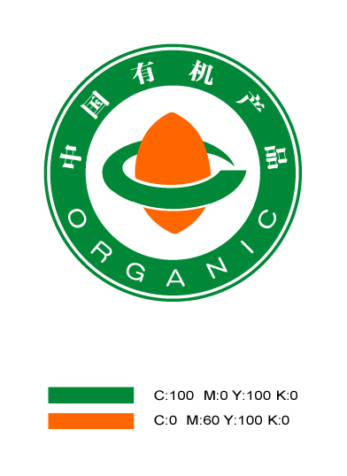
Graphic 1: Organic Product Certification Seal of China

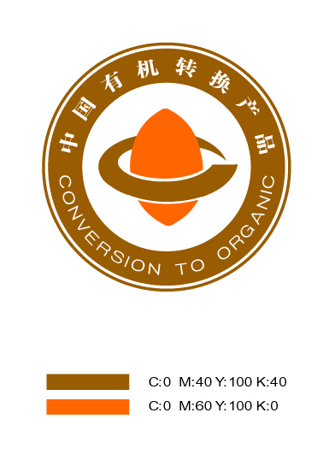
Graphic 2: Conversion to Organic Product Certification Seal of China
7.3 According to the product character, Organic Product Certification Seal of China and Conversion to Organic Product Certification Seal of China shall be either affixed to packages as a sticker, or printed directly on, and will be affixed on the product or the smallest package. For the products in bulk, products without packaging, and live animal products, the Organic Product Certification Seal of China and copy of the certificate shall be shown in appropriate position of organic sales location. Raw materials do not have to be affixed with the seal if used only for processing and not for retail.
7.4 Printed Organic Product Certification Seal of China and Conversion to Organic Product Certification Seal of China shall be clear and prominent.
7.5 Organic Product Certification Seal of China and Conversion to Organic Product Certification Seal of China printed on labels, instructions and marketing materials of the products shall be enlarged or reduced in size without any change to the shape and color.
8. Requirements for marketing
8.1 Sellers shall adopt but not be limited to the following measures to keep integrity and traceability of organic products during organic marketing:
- to prevent commingling of organic products with non-organic products;
- to prevent contact of organic products with prohibited materials of this Standard; and,
- to keep records of purchasing, transportation, storage, incoming and outgoing and sales for organic products.
8.2 When organic products arrive, the sellers shall request suppliers to provide organic certificate, organic product transaction certificate and other proving documents. Products containing less than 95% organic ingredients and labeled as “Produced with Organic Ingredients” shall prove the origin of organic ingredients by proof-of-organic documents.
8.3 Authenticity of the organic certificate shall be verified and a copy of the certificate shall be kept by both the producer and sales person.
8.4 For products sold in bulk, products without packaging and live animal, organic dedicated sales or display counter shall be set up in marketing areas and be separated from counter or area for non-organic products.
8.5 A copy of the organic certificate shall be displayed prominently in sales or display counter for organic products.

